**Lab # 5**  
*NETWORK ANALYSIS*

Name: Mahum Manzar

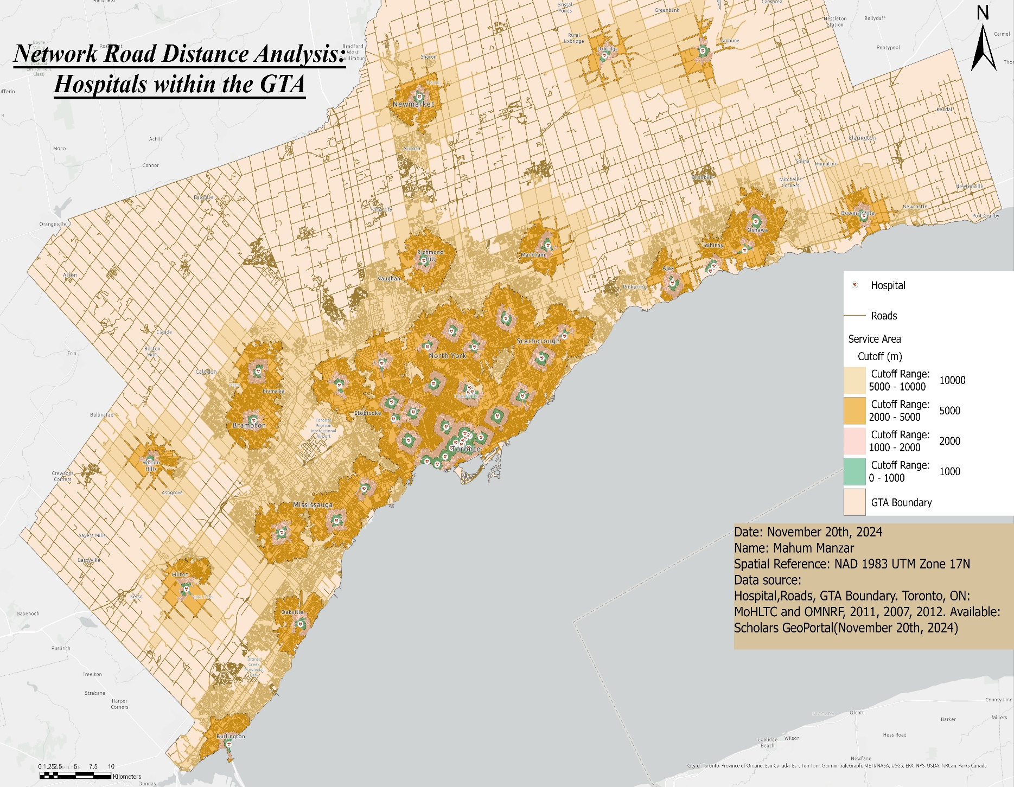

**QUESTIONS:**

**1.** The closest hospital to Vari Hall, York University, based on the analysis, is Humber River Regional Hospital. It falls within the 0-1 km (1,000 meters) distance range.

**2.** If I were tasked with situating a new hospital in the GTA, I would consider building it further north, in areas like Blackwater, Zdora, or Zephyr. These areas have fewer hospitals, and placing one there would improve accessibility for residents. It would reduce the need for people to drive long distances to the nearest hospital in Uxbridge and provide quicker access within a 2 km range.

**3.** The assumptions made during the analysis are not equally valid for all scenarios. The analysis is based on road distance, which benefits drivers but does not accurately reflect the experience of pedestrians. Walking distances are impacted by additional factors such as traffic lights, crosswalks, and walking paths, making it slower compared to driving. Therefore, while the assumptions work well for drivers, they are less applicable for pedestrians.